**Computational Linguistics**

**Question 1 – EM Algorithm**

Relative Frequency and Maximum likelihood estimate. Include a plot.

Give Explanation of this formula

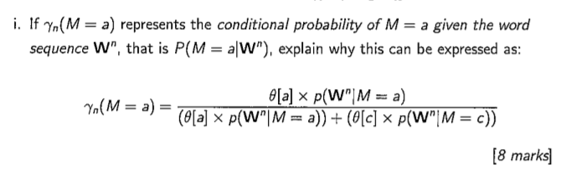

Crucial guaranteed property of EM algorithm that underlies its adoption. (attractive property)

Known potential drawbacks to the procedure. (unattractive property)

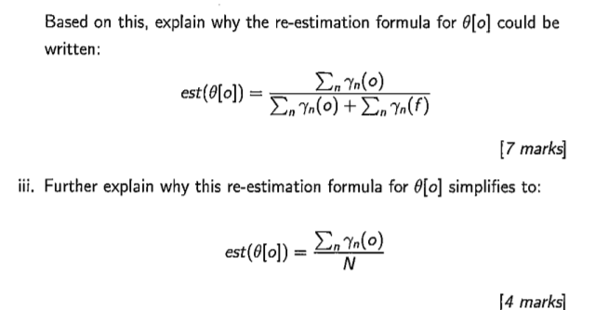

Give a formula for P(Sequence), the probability of the sequence of outcomes.

Be able to derive re-estimation formula for EM algorithm.

Be able to show for the bottom line,

yn(o) + yn(f) = 1.

En Yn(o) + En Yn(f)

En Yn(o) + Yn(f)

En (1)

== N

**Question 2 - IBM Models**

Sum of products to product of sums conversion.

Perform iterations using EM for IBM

